PIG IRON
All Grades · Full Specifications · Export from India
BIS IS 13602 Compliant · Basic · Foundry FG1–FG4 · SG Nodular · HPPI · FOB Goa / Vizag / Nhava Sheva

Section 1 — Hero Content
Indian Pig Iron — Basic, Foundry, SG Nodular & High Purity Grades — Export to Middle East, Southeast Asia & Beyond
Sub-headline: Fe 92%+ · C 3.5–4.5% · BIS IS 13602 compliant · Container lots from 20 MT · FOB Goa / Vizag / Nhava Sheva

Buyer CTA: "Request a Quote / Sample Analysis"
Supplier CTA: "Supply Pig Iron to Us"
- COA with every lot · SGS inspection available
- WhatsApp + phone — Middle East foundry buyers and Bangladesh steel mills contact by WhatsApp first

Section 2 — Trust Bar (5 Scannable Stats)
- MT exported per year / number of countries supplied
- Years in pig iron trading and export
- Grades available: Basic · FG1–FG4 · LP Foundry · SG Nodular · HPPI · Low Mn Basic
- Packaging: 20 MT container lots
- Lead time:15 days from order to container loading

Section 3 — All Indian Pig Iron Grades — Full Specifications
All grades below are commercially available from Indian blast furnace plants.

Additional notes:
- Physical form: ingots / pigs — approx 5–8 kg each · size 140mm × 140mm × 70mm (standard Indian pig)
- COA provided per lot: C, Si, Mn, S, P, Ti, Fe — by XRF or optical emission spectrometry (OES)
- BIS IS 13602:1992 consolidates IS 224 (foundry), IS 2841 (special) and IS 2842 (basic) — grade certification available
- Custom chemistry within range available for regular buyers of 100 MT+/month

Section 4 — Which Grade Do You Need? Quick Guide

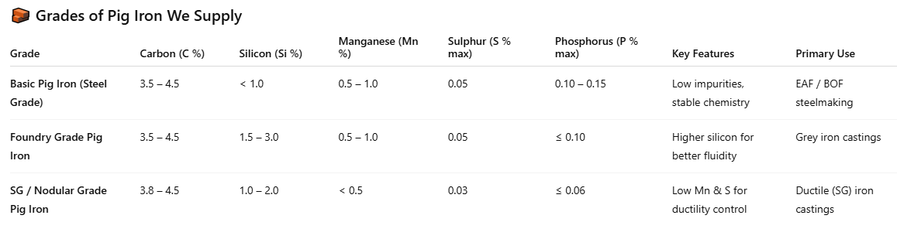

Section 5 — Industry Applications
- Foundries (grey iron): cupola and induction furnace foundries making engine blocks, agricultural castings, machine tool bases, pipes, manhole covers — foundry FG grades; Si content determines graphite morphology and casting properties
- Ductile iron foundries: pipes (ISO 2531), automotive knuckles, brake callipers, wind turbine components — SG nodular or HPPI; key requirement: Mn below 0.3%, S below 0.03% for magnesium nodularisation to work reliably
- EAF / induction furnace steelmakers: pig iron as clean scrap substitute — dilutes tramp elements (Cu, Sn, Cr, Ni) from scrap charge; basic grade used in flat products and quality long products
- Stainless steel route: low P and low S basic grade as clean iron source for stainless melt shops where phosphorus is critical
- Automotive OEM supply chain: India supplies Tier 1 and Tier 2 foundries globally — Toyota, Hyundai, Bosch supplier foundries in Thailand, Indonesia, South Korea use Indian foundry and HPPI grades
- Infrastructure castings: manhole covers, drainage gratings, lamp-post bases, road furniture — mid-range foundry grade; large volumes per project
- White goods / engineering: pump bodies, compressor housings, electric motor frames — grey iron, low P foundry grade

Section 6 — Why Buy From Us — Buyer Advantages

Quality & Consistency  - Fixed plant source — same blast furnace, same chemistry lot to lot  - Full COA: C, Si, Mn, S, P, Ti per shipment — no surprises in your furnace  - — grade-certified material  - SGS / Intertek inspection at loading port available on request  - Reference sample retained per lot — traceable for any quality query | Supply & Pricing  - Direct plant source — no middlemen, competitive FOB price  - Container lots from 20 MT — no vessel minimum required  - Long-term supply contracts available — fix volume and price cycle  - Multiple grades from one supplier — simplify your procurement

Technical Support  - Grade selection support — share your application, we recommend  - Chemistry customisation for regular buyers of 50 MT+/month  - Technical data sheet per grade with typical casting properties  - Trial lot with full COA before long-term commitment  - Metallurgical queries answered — we understand foundry applications | Logistics & Documentation  - Export from Mormugao (Goa), Vizag, Nhava Sheva, Chennai  - 20 MT container: ~400–500 pigs per FCL, palletised or loose  - Full docs: BL, COA, packing list, commercial invoice, COO, MSDS  - Flexible incoterms: FOB, CFR, CIF  - Payment Terms – TT, *LC

Section 7 — Partner With Us — Supplier Advantages

Better Price Realisation  - Export market pricing — consistently above domestic foundry rates  - Grade-linked pricing — HPPI and low P grades earn meaningful premium  - Consistent monthly buying — no boom-bust in your despatch volumes  - No arbitrary quality deductions without COA evidence | Reliable Offtake  - Monthly committed purchase quantity — plan your blast furnace campaign  - We absorb export demand variation — your production moves consistently  - Long-term supply agreement for plants wanting volume certainty  - We handle all export documentation, freight and compliance

Payment That Works For You  - Payment on committed timelines — always know your settlement date  - Structured payment cycle aligned to your casting and despatch schedule  - No delays — we operate on confirmed export receivables  - Transparent settlement — bank transfer with clear invoice reference | Partnership & Support  - Free chemistry verification of your material before you commit  - Guidance on meeting export grade specifications if needed  - Access to our international buyer network for additional channels  - No exclusivity — supply us alongside your existing domestic buyers

Supplier enquiry form fields: Company name · Plant location (State) · Grade produced · Monthly output (MT) · Typical chemistry (C / Si / Mn / S / P) · Contact number

Section 8 — India's Pig Iron Industry — Why Source From India
- India's annual pig iron production: ~8–9 Million MT/year; significant merchant / exportable surplus especially from Goa and Chhattisgarh-based plants
- Key producing regions: Goa (Sesa Vedanta — largest merchant producer, 0.95 MTPA capacity), Chhattisgarh (Raipur / Bhilai cluster), Jharkhand, West Bengal, Odisha
- Competitive advantage: Indian pig iron is competitively priced vs Brazilian, Russian and Ukrainian origins; consistent quality from major BF plants; accessible in container lots — no vessel-minimum required for most grades
- Export markets actively served: UAE, Saudi Arabia, Qatar, Bangladesh, Sri Lanka, Indonesia, Vietnam, Malaysia, South Korea, Egypt, Nigeria
- India's pig iron known for: low tramp element content (clean iron units), reliable chemistry from well-operated BF plants, BIS-certified grades, proximity to Gulf and Southeast Asian markets — freight advantage vs Brazil or Russia
- requiring it (some Gulf ports)

FREQUENTLY ASKED QUESTIONS

Q1. What types of pig iron are available?
We supply:
- Basic Pig Iron – for steelmaking
- Foundry Grade – for castings
- SG Grade – for ductile iron

Q2. Why is silicon (Si) important?
Silicon controls casting properties.
- Higher Si → better fluidity
- Lower Si → higher strength

Q3. What is SG pig iron used for?
SG pig iron is used for ductile (nodular) iron castings, requiring low sulphur and controlled chemistry.

Q4. What is the minimum order quantity?
Minimum order is typically one container (20–25 MT).

Q5. Do we provide test reports?
Yes, we provide COA (Certificate of Analysis) with every shipment and can arrange samples if required.

Q6. Is Indian pig iron reliable?
Yes, Indian pig iron is known for consistent quality and stable supply, especially for nearby export markets.

Q7. What are the payment terms and delivery time?
We work with TT / LC.
Delivery is usually 15 days from order confirmation.

